Lesson 1: Probability; Discrete Random Variables

Preparation

**Directions: Please fill in Part I as you study the Reading Assignment. Once you finish the reading, complete the questions on Part II. You may use your notes, the key, and the help videos. Be sure to take this completed assignment to your group meeting where you can ask and help answer questions on this assignment.**

## Problems

**Part I:** Use the information in the reading assignment to complete these questions.

1. What notation is used to denote the probability of an event occurring?
2. Please state and describe the three rules of probability.
3. What does it mean to be random?
4. What does the phrase Discrete Random Variable mean?

**Part II:** You will fill this part out during your Group Preparation session.

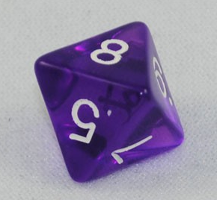

1. An eight sided die has eight possible outcomes for each roll. (1, 2, 3, 4, 5, 6, 7, or 8). Calculate the probability of rolling a number greater than 5.
2. Calculate the probability of not getting a number greater than 5.